AVAC officers virtually inducted

Cebu City—The newly-elected officers of the Association of Voluntary Arbitrators in Central Visayas, Inc. (AVAC) was recently inducted into office by no less than NCMB Executive Director Maria Teresita D. Lacsamana-Cancio via Zoom platform.
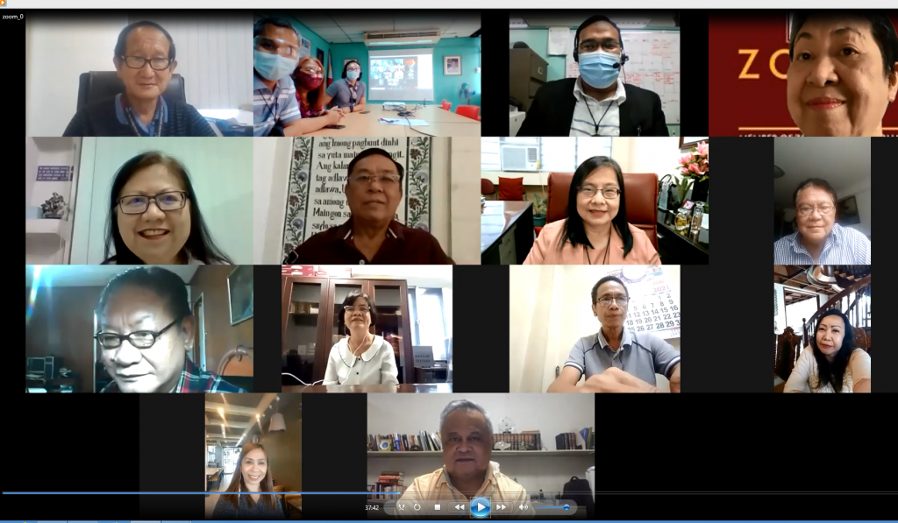
Spearheading the new rooster of officers who will serve for a two-year term is the elected President AVA Perfecto Delos Reyes.
“Thank you for putting your trust in me. It is with great pride and honor to accept the presidency.” AVA delos Reyes said.
In his acceptance message, he hoped that with the full support and help of the rest of the officers the forthcoming endeavors of the association will be successful.
“I take your induction ceremony as a joyous celebration of victory and unity.” shared Director Cancio during her inspirational message.
This according to her, is the victory over the difficulties and complexities of running an organization and managing its affairs especially now, and unity for staying as one, working and championing the association’s ideals, goals and objectives.
She expounded that voluntary arbitration will stay relevant as labor disputes continue to rise and its relevance should be felt and acknowledged.
On one hand, Atty. Jocelyn G. Pesquera, the outgoing President and at the same time the newly-elected Vice President felt happy to have virtual induction and first general assembly.
She also hoped to come up with more activities despite the pandemic.
The virtual ceremony was also graced by PAVA President Atty. Michael L. Rama.
Other elected officers were: Ms. Cynthia Barrit- Secretary, Atty. Geraldine E. Jorda-Treasurer, Ms. Catherine Son-Lauzon- Auditor, Atty. Amadeo Seno Jr. and Atty. Manuel M. Monzon- PROs.
The Board of Directors were: Atty. Manuel P. Legaspi, Atty. Rolando M. Lim, Atty. Anecita G. Pasaylo, Mr. Melchoir A. Marquez, Atty. Alice C. Morada and Atty. Michael L. Rama.
AVAC is a strong and dynamic organization composed of competent accredited voluntary arbitrators contributing to sound labor-management relations in Central Visayas through voluntary arbitration as the better mode of labor dispute settlement.
posted: June 1, 2021
Source: https://rcmb7.ncmb.gov.ph/avac-officers-virtually-inducted/

